**Test Document for Modification in report Payment detail IRN wise**

Label changed “Only received" to “Only Not Copied”

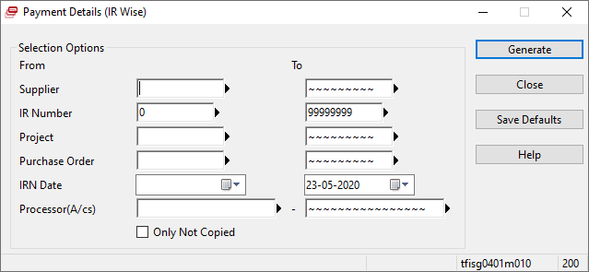

Testing for ES0128

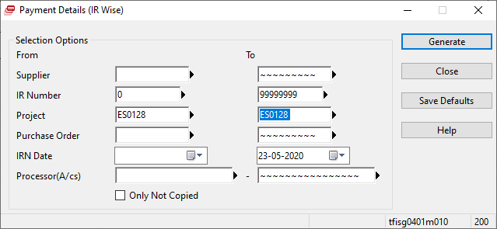

Results are:

